Tiffany Gray
Writing Sample
19th-Century Women’s Expansion of Language
through Fashion STATEMENTS
Introduction: Making a Fashion STATEMENT
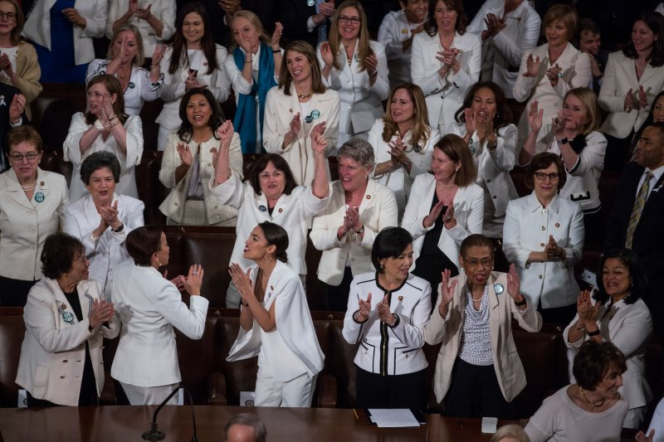
While the focus of 19th-century women’s fashion to make a STATEMENT focused on utilizing their “traditional femininity” as a form of activist language to enter the public sphere, fashion STATEMENTS today project a different focus, but one that is no less activist in nature. During the 2019 and 2020 State of the Union Addresses, Democrat women representatives coordinated together to all wear white to the meetings (Figure 1). As noted in Time magazine, the congresswomen chose to wear white “as a way to show their unity and a commitment to defending the rights of women and disenfranchised groups” (Lang 2020). While the purpose of wearing white to both events was to harken back to the fashion STATEMENTS of women suffragists who wore white in solidarity regarding women’s right to vote, the 2019 effort sought to showcase what Rep. Rashida Tlaib identified as wanting “to show all the young girls across the country, [and] all the young women the women’s rights movement hasn’t stopped…” (Lang 2019). In 2020, women across the United States celebrated the 100th anniversary of the ratification of the 19th amendment, which allowed women the right to vote, and as such, Democrat congresswomen again chose to wear white in honor of this historic event (Lang 2020). Unlike 19th-century women, 21st-century women have more exposure and voice in the public arena, as evidenced by women serving in the roles of Speaker of the House and Vice President of the United States. Yet, just like their predecessors, women today purpose a language that is traditionally gendered towards women’s use of fashion and textiles to enter the public space, projecting an ecological ethos that is a presence of both body and embodiment, to make a fashion STATEMENT.
Figure 1. Gibson, Zach. “Democratic members of the House of Representatives at the 2019 State of the Union address in the chamber of the U.S. House of Representatives on Feb 5, 2019 in Washington, DC.” Getty Images, 2019.

From Statement to STATEMENT
“Making allowance for the novelty of the thing, we cannot discover anything either unnatural or immodest in a Christian woman, becomingly attired, appearing on a platform or in a pulpit” (3).
-Catherine Booth
Throughout this paper, I have chosen to emphasize the word STATEMENT by placing it in all capital letters. My purpose for this is to indicate that 19th-century women, and by extension all women in any period who used their clothing and textiles as a form of activism, did not use fashion to speak for them, but rather, they used fashion as an extension of their voice and as part of their means to speak. Thus, clothing and textiles are not making a statement on behalf of the women, like what might be said about fashion lines worn on the catwalk for the latest Spring line, but, rather, women use their fashion to assert a position of activism and authority as a form of ethos to make a rhetorical STATEMENT. I find this distinction necessary and important because for 19th-century women, entering the public sphere with the intention to engage in public discourse required the employment of any available application of language communication possible to justify and make allowances for “the novelty” of their entrance. Given the historically relegated place of women to the domicile, one approach 19th-century women took to move outside their bounds of the home and into the public arena included embracing their domestic qualities and practices with the intention of using them as a form of activist rhetoric.
To be both seen and heard, women of this era utilized a verbal and a visual language to present an ethos-based persona built upon the ideals of a traditional, Christian woman. As Booth’s quote above indicates, women who projected the societally accepted image of a “Christian woman” should be able to speak because their visual/verbal display of their consigned position is denoted by her appropriate dress and, being a Christian woman, her inclination to only speak of things more in line with her place in society (3). While Booth’s words represent a willingness on women speakers to conform to socially controlled expectations of women’s expected dress, Carol Mattingly notes that “...if dress became a means of control, a way of discipling women, it also provided an effective means of resistance because women speakers often recognized that their dress discourse might discipline what and how their audience heard” (25). Therefore, 19th-century women’s use of fashion and textiles to create a visual language, one in which promoted or detracted an audience’s willingness to listen to the speaker, allowed women an opportunity to actively engage in public discourse and dialectic exchange through a visual as verbal fashion STATEMENT.

Method: Redefining Language
In the late 17th century, rhetoric, and the understanding of language as both a tool of communication and persuasion, saw a neoclassical return to Ancient Greek philosophies. Harkening back to the ideals of early Sophists like Parmenides and Gorgias, scholars of the Enlightenment era sought to return the study of rhetoric back to examining the relationship between truth and knowledge as they related to language and discourse. However, the return of classical thought to rhetorical studies at the start of this era also encouraged an expansion of views regarding what language is. John Locke first began to assert that language is not only a discursive tool to achieve understanding but that verbal language is also a mode of communication of one’s thoughts as well. Locke notes that ideas “are differently discovered by different men, according to their various skill, attention, and ways of handling” and that “when any word does not excite in the hearer the same idea which it stands for in the mind of the speaker” verbal language, then, lacks in mutual signification between the speaker and the hearer resulting in unrelatability and uncertainty about the validity of verbal language to clearly convey thoughts and truth (Locke 890-894).
In recognizing the limitations of viewing language as solely verbal, late 18th -century elocutionist Thomas Sheridan sought to reimagine the relationship between language and thought by expanding the definition of what counts as language. One of the first to identify the concept of non-verbal communication, Sheridan writes in A Course of Lectures on Elocution that “For language, in its full extent, means, any way or method whatsoever, by which all that passes in the mind of one man, may be manifested to another,” (Sheridan 965). By expanding language to include more than just words spoken and words written, Sheridan’s essay further challenges that language has no essential part except through customs relative to those whose language is in practice (Sheridan 967). Thus, by Sheridan’s standard, language communication is not limited to verbal cues only, but can include visual communication as found in body language. Even further than the role of body language in communication, and of significant importance to the idea of expanding what counts as language for women of the 19th-century, is Sheridan’s ideas that language is relative to those who speak and/or use it. Therefore, because women have used language differently than men, the expansion that Sheridan offers is that finding their place in the rhetorical history by broadening language to mean “any way or method whatsoever,” both allows and requires scholars to look at women’s rhetoric to include their available means of language, by looking beyond the visual cues of body language and add the flourishes and STATEMENTS made through their fashion.
Methodology: Rethinking Ethos
By applying Sheridan’s expansion practice of redefining what counts as language, 19th-century rhetoric scholars have further sought to expand the ideas of what counts as rhetoric, or the use of language to persuade. For scholars, utilizing current and emerging theories allows the opportunity to read into the rhetorical tradition voices and examples of rhetorical practice that have previously gone (un/under)studied for reasons of prevailing hegemonic powers, lack of available materials to study, or simply not knowing certain individuals or peoples exist. Regarding woman’s presence in the rhetorical tradition, Cheryl Glenn calls on scholars to look beyond the borders of the traditional canon of rhetoric, to “locate female rhetorical accomplishment within the male-dominated and male documented rhetorical tradition that it interrogates” (69). Her call not only asks for consideration of female voices, but how their language is presented from their womanly perspective. Similarly, Carol Mattingly notes, “Since many of the traditional tools of rhetoric were denied them, women found it necessary to consider techniques beyond the customary attention to argument and delivery for male speakers” (25-26)​. Thus, as Mattingly and Glenn indicate, finding women’s texts and forms of rhetorical practice require investigation into other modes and modalities of what is considered rhetoric. Feminist Rhetorical Theory, as presented by Letizia Guglielmo, allows for one such exploration of women’s voices and language, where the focus is on (un/dis/re)covering not only the language of those traditionally silenced, censured, or erased, but also studying the means women did take in order to publicly speak (Guglielmo).
Scholar’s attempts to reassess what counts as rhetoric have led to further investigation into methods and methodologies of how to expand traditional rhetorical terms, like ethos, when applied to non-traditional modes of discourse. To support the claim of 19th-century women seeking to establish an activist ethos built from their domestic space, recent scholarship has turned to identifying women’s ethos as associated with the entirety of her rhetorical exposure. Patricia Bizzell writes that ethos is tricky because, “...it makes its impact in the opening moments of a speaker’s address, as we take in her physical appearance, clothing, vocal tones, and immediate surroundings without necessarily noticing that we are doing so” (384). As Bizzell’s reading of ethos indicates, ethos is not limited to Aristotle or Quintilian’s views of arete or the qualities of a “good” man, but rather, ethos is the figure of the person, in the space with which they are rhetorically engaging, affected by both the setting behind her and the audience before her.
In expanding Bizzel’s notions of ethos, Kathleen Ryan, Nancy Myers, and Rebecca Jones make the case for an ecological “rethinking of ethos” where, “Feminist ecological ethe open up new ways of envisioning ethos to acknowledge the multiple, nonlinear relations operating among rhetors, audiences, things, and contexts…” As such, scholars can then view “any rhetorical situation as shifting and morphing in response to others (persons, places, things), generating a variety of plurality of ethos, or ethe” (Rethinking Ethos 3). By reading women’s ethos as all-encompassing regarding place and space, body and embodiment, and speaker to audience, scholars can read multiple ethos appropriations by women, all of which represent an activist rhetoric because they are actively engaging in speaking their language by the means that are both appropriated and available to them. Thus, by using feminist rhetorical theory in conjunction with Ryan, Myers, and Jones’ ecological ethos lens, I will explore 19th-century women’s use of fashion to make an activist STATEMENT and find entrance into the public sphere discourse.
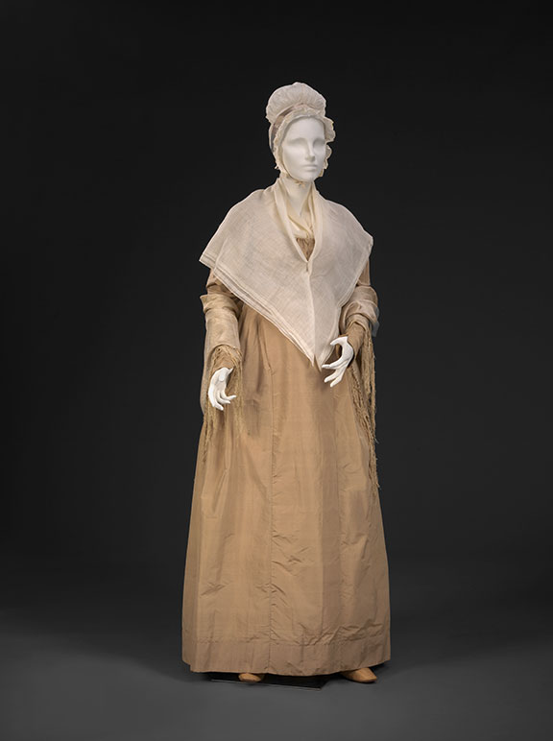
Fashion STATEMENTS: Women’s Clothing and Textiles as Ethos
Figure 2. Quaker Dress. “An Agreeable Tyrant: Fashion after the Revolution,” DAR, 1810, agreeabletyrant.dar.org/gallery/1800-1810/quaker-dress/.

Discovering entry into the public forum came in multiple varieties of fashion STATEMENTS for 19th-century women. Reiterating Ryan, Myers, and Jones’ ecological ethos approach, not all women, neither individually nor collectively as a community, took the same approach regarding ethos as a fashion STATEMENT. For middle-class, religious women seeking the right to preach, Carol Mattingly has explained that dress often took on a visual ethos of the pious, comely, socially acceptable Christian identity, where dress was plain and modest (Figure 2). She writes:
…the best known and most effective women speakers wore Quaker attire…Since purity was a prerequisite for credibility and respectability for nineteenth-century women, and convention held that purity was impossible for women except in the domestic, a visual image that evoked sentiments of morality and purity prepared an audience better than any other dress could have to seriously consider the speaker (27)​
Patricia Bizzell makes these same assertions, in describing the ethos of Frances Willard and Phoebe Palmer. Bizzell describes that Phoebe Palmer “presented an obviously middle-class physical appearance, well dressed and living in a comfortable home…[while] at the same time, she exercised such restraint in the matter of personal adornment, eschewing jewelry, laces, and other feminine embellishments…” (386). As Bizzell explains, Palmer desired to project the traditional, societally acceptable style of women to gain the right to speak from the pulpit, even though her right to speak was limited to reading sermons from men and not preaching herself (384). Similarly, Bizzell, in quoting extensively from Ruth Bordin’s Frances Willard: Biography, describes Frances Willard as projecting a parallel style to that of Palmer, stating:
...a middle-class Methodist physical appearance, womanly, to be sure, and dressed in “a becoming costume, usually a simple well-cut brown or black dress with a sky-blue tie at the throat” (Bordin 108). The modesty of her dress was enhanced by her principled opposition to tight corsets and elaborately bunched and trailing skirts, fashions intended to exaggerate her era’s most admired type of female form (see Bordin 122-123) (388).
As Mattingly and Bizzell both describe, 19th-century women seeking opportunity to speak from the pulpit, even as lay women preachers, chose a visual fashion STATEMENT that was socially conforming, but, which in turn, afforded them the right to speak because they were dressed according to social conventions.
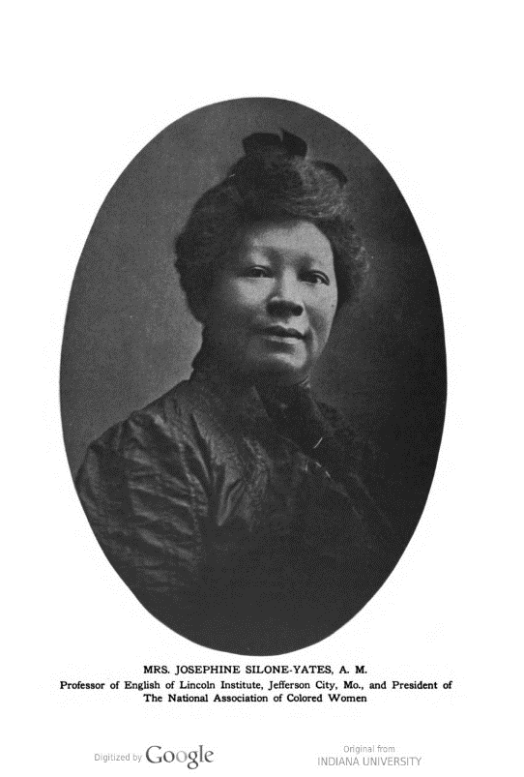
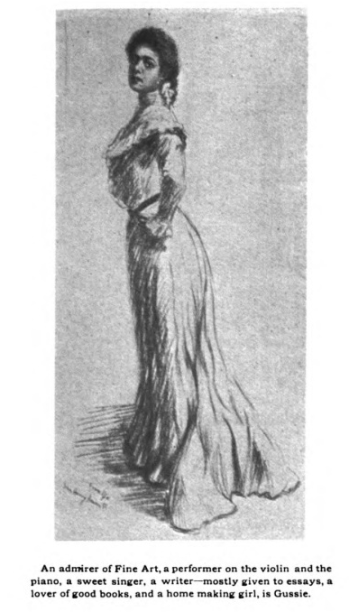
Unlike 19th-century women preachers, women of the African American community sought a different visual image to guide their own narrative and entrance onto the public stage. Kristie Fleckenstein uses the theory of collective identity to describe the two contrasting ethos that Black American women presented as the New Negro Woman of the post-civil war era. The first image that Fleckenstein describes is that of the “Aesthetic Daughter” (Figure 3). Using the sketch of Gussie from the 1904 publication of The Voice of the Negro, Fleckenstein describes efforts by the Black community to present the image of young, Black women as refined, educated, and cultured, dressed in a style that is fashionable and becoming (251-253). Contrastingly, the Black community also emphasized a counter-narrative ethos of the “Civic Mother” (Figure 4), or, as Fleckenstein describes a Black woman figure who is disconnected from the aesthetic daughter, by using photography instead of high-art sketches of noted Black women to describe the civic mother’s qualities as “gifted intellectuals and writers” who are real women, in real dress of fashions available for all Black women (257). In other words, the “Civic Mother” sought to project an ethos of real women who use their education, instead of fictitious drawings of women as in the “Aesthetic Daughter” who only possess one. As Fleckenstein notes, the contrasting collective identity rhetorics of 19th-century African American women represent the larger goal of Black Americans seeking to “control…their own visual representations” while, simultaneously gaining “recognition of their contributions to cultural enrichment,” through high end sketches and photography. So, while the collective identities of 19th-century African American women seem at odds with one another, their overall objective in presenting fashion STATEMENTS was to stand in solidarity with projecting their own ethos, while maintaining fluidity in how their ethos is shared (Fleckenstein 262). Thus, fashion as ethos allowed 19th-century women to not only assert their own position within the given community that they belong to, but also to claim a level of control over the narrative of their space and place in society.
Figure 4. “Josephine Silone-Yates.” The Voice of the Negro, vol. 1, no. 7, July 1904, p. 266. HathiTrust, hdl.handle.net/2027/inu.32000013344009.
Figure 3. 1. “Gussie.” The Voice of the Negro, vol. 1, no. 6, June 1904, p. 326. HathiTrust, hdl.handle.net/2027/inu.32000013344009.
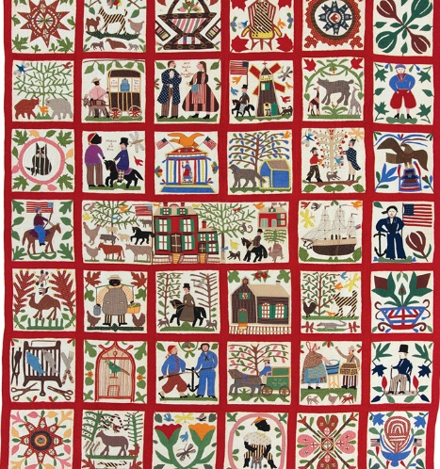
19th-century women not only used wearable fashion to display and embody a visual as verbal language and rhetoric. The use of textiles, such as quilts and insignia that resembles traditional woman textile activities of sewing and looming, also contributed to the work of women using fashion STATEMENTS as activist rhetoric. Vanessa Kraemer Sohan explores the quilting practices of two quilting clubs, the Townsend and Gee’s Bend quilting clubs, both of which engage in a non-traditional version of rhetoric with textiles. Sohan notes that, quilting, a customary practice among women, “...represents their makers’ literacies - their “way of being in the world, [and their] forms of life - as well as their histories” (115). As such, the textile work of quilting provides several avenues of rhetorical practice examination, from the practice of quilting itself to the modes of discourse engaged in during the quilting process, to the quilting creations made by the quilting clubs. Some quilts, like the “Reconciliation Quilt” from 1867, made by Lucinda Honstain and Emma Bingham after the Civil War, are created as forms of public dialogue to encourage didactic engagement (Figure 5); while others, like the quilts my grandmother made for her children and grandchildren, represent an expression of familial attachment and a desire to pass on a generational practice.
Figure 5. Lucinda Ward Honstain and/or Emma Honstain Bingham. “Reconciliation Quilt,” 1867. internationalquiltmuseum.org/exhibition/evolving-vision-classics.
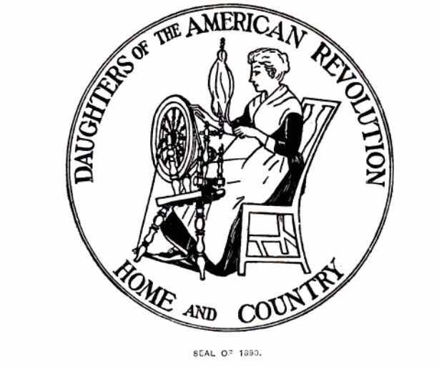
Parallel to the visual rhetoric of quilting is the verbal rhetoric that uses textile work metaphorically to promote civic discourse. Jessica Enoch relates that when the Daughters of the American Revolution (DAR) organized in the late 19th-century, they did so to combat growing changes in their social climate. However, as Enoch explains, the DAR practiced memory making with an air of attachment to traditional, conservative womanly activities. Enoch quotes Jane Meade Welch’s comment that women of the DAR had the responsibility for “...the embroidering of history” by helping to establish the narrative of the American story (207). Enoch elaborates that the purpose for “this all-women’s group was to “perpetuate the memory of…men and women” by crafting history and public memory in a way that was metaphorically engendered as and equated with the feminine practice of embroidery” (207). In tandem with the verbal use of the term embroidery, Enoch also shares the DAR’s seal, which is “the image of a woman at the spinning wheel” (Figure 6). However, as Enoch indicates by pairing “the key practice of the organization - memorialization - with that of threadwork, a feminine activity that would not traditionally be endowed with civic importance,” the DAR effectively evokes an activist image because it applies a traditionally feminine activity with a publicly organized women’s effort (216). Thus, while embroidery work and the image of women at the loom do not readily draw connections of textile work with activism, Enoch concludes that “...we might also read in this image [and by extension, terminology of embroidery] the DAR charging its form of feminized gendered activity with power,” a power that equates to women’s activism through an established rhetorics of cloth, clothing, and textiles (216).
Figure 6. DAR Seal. 1890. Daughters of the American Revolution. Report of the Daughters of the American Revolution, 1890-1897. Government Printing Office, 1899, p.41.

Issues and Dangers of Appropriating Fashion STATEMENTS
By embracing their traditionally defined personas, 19th-century women used their fashion STATEMENTS to project an ethos built from their socially accepted image. While feminist rhetoric theory and Ryan, Myers, and Jones’ ecological ethos approach encourage and promote looking for voices outside the rhetorical canon in various and diverse locations, an important counter-narrative regarding the dangers of 19th-century women’s fashion STATEMENTS needs recognition because not all women’s fashion STATEMENTS achieved the desired result. Some women who wanted to join the cause could not because they did not fit the socially acceptable embodiment of the ethos they chose, while other women risked their health just to maintain the freedom that fashion STATEMENTS provided them. Similarly, not all 19th-century society was ready or accepting of women and their fashion STATEMENTS. As 19th-century rhetoric scholars, we must maintain a cognizance that our research always includes or excludes certain individuals or communities, and we run the risk of over appropriating women’s ethos to specific genres while simultaneously creating a historiography that is myopic in focus.
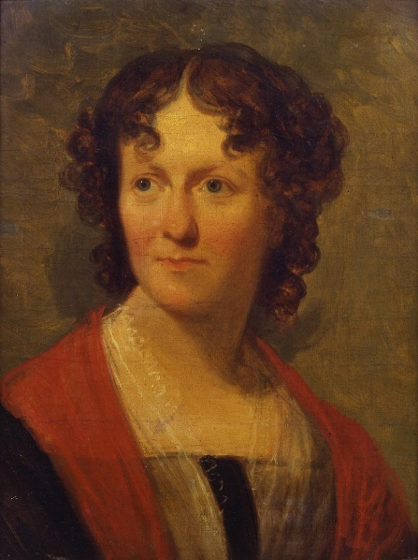
To begin, even though certain trends of fashion STATEMENTS are discernable among certain genres of activists from 19th-century women, examples of “other” women desiring to belong or disassociate with a particular ethea are also an important narrative of 19th-century women’s fashion STATEMENTS. Often “othered” because they do not fit within the historiography of a movement, some 19th-century women went against traditional women’s clothing with the purpose to claim their voice, but found little support in the broader community for their efforts. Carol Mattingly writes of Frances Wright who early in the 19th-century pushed gender boundary conformity by choosing to wear tunics and pants while vocally speaking out against slavery (28) (Figure 7). Mattingly writes “[Frances Wright] regularly faced opposition that labeled her a “petticoated politician” or a “lady-man” (Eckhardt 224), and critics capitalized on the fear and anxiety surrounding gendered deviations from the norm” (28).​ Instead of embracing the Quaker dress of middle-class women seeking a platform in the public arena, Wright chose to buck convention and attempt to insert herself in public discourse much to the dismay and displeasure of the dominant powers that be.
Figure 7. Henry Inman. Frances Wright (1795-1852). https://jstor.org/stable/community.21769293. <a href="https://www.nyhistory.org/">New-York Historical Society</a>;Purchase, Abbott-Lenox and Foster-Jarvis funds, and the James S. Cushman Bequest.
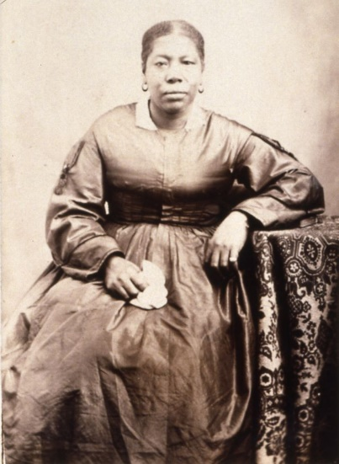
In contrast to Wright’s negation of traditional gender apparel, other women sought to embrace certain fashion STATEMENTS, but found little success in their efforts because they did not physically embody the fashion STATEMENT in its entirety. Jane Manning James, one of the first African American women to join the Church of Jesus Christ of Latter-day Saints, sought to find a place within Latter-day Saint women’s Utah society by embracing their high collar, long sleeved, simple black dress fashion (Figure 8). Max Perry Mueller describes James’ picture, stating, “From her choice of fashion to her stern, unsmiling face and stiff pose, Jane Manning James’s image…is the model of Mormon Respectability…Despite her blackness, James asserts that she has successfully conformed to the standards of piety and bodily discipline that should earn her a place in the white, Mormon sacred community…” (212)​. However, as Mueller further explains, even though James desired to belong to the ethos image of white, Latter-day Saint women of the late 19th-century, issues of racism within the early Church left James without complete acceptance into the established Latter-day Saint woman persona (Mueller 212). Therefore, the complete negation of or lack of embodiment for a particular ethos resulted in other 19th-century women, like Wright and James, to not find a place within the ethos they desired to belong to. While Wright sought aggressively to move past traditional women’s fashion and past the ethos women used to enter the public space, James could not fully belong to the ethos she desired because her Black body prohibited entrance at that time. For both women, their ethos was lost, taken, or marginalized because they could not fit into the narrative of perceived 19th-century women’s fashion STATEMENTS.
Figure 8. George A. Smith photograph collection, circa 1862-1895; Photographs; Jane Manning James photograph; Church History Library, catalog.churchofjesuschrist.org/assets/d48586fd-9aab-456e-b0f9-aa8d8f3f5f09/0/0.
Parallel to not belonging to a particular ethos is the issue of a fractured ethos within a community, that results in a lack of unification and identification among the community’s members. For 19th-century Black women as described in Fleckenstein’s Aesthetic Daughter and Civic Mother, the divergent identities that Fleckenstein addressed also shows the fissures that exist within a community that seeks to create a collective identity. She writes:
The Black public sphere thus constituted itself out of multiple voices and perspectives, exposing asymmetrical power dynamics within the African American community. This public sphere afforded African Americans not only the resources to form a collective identity out of those multiple voices but also the resources to fracture that identity (251)
As Fleckenstein indicates, multiple voices within a community allow for diversity and variety in approach to a collective ethos. However, those differences in ethos identity, as found in the contrasting images of the Aesthetic Daughter and Civic Mother, create points of disjunction and disunity in the collective identity of the community, resulting not only in conflicts within the community itself, but also acceptance from society at large.
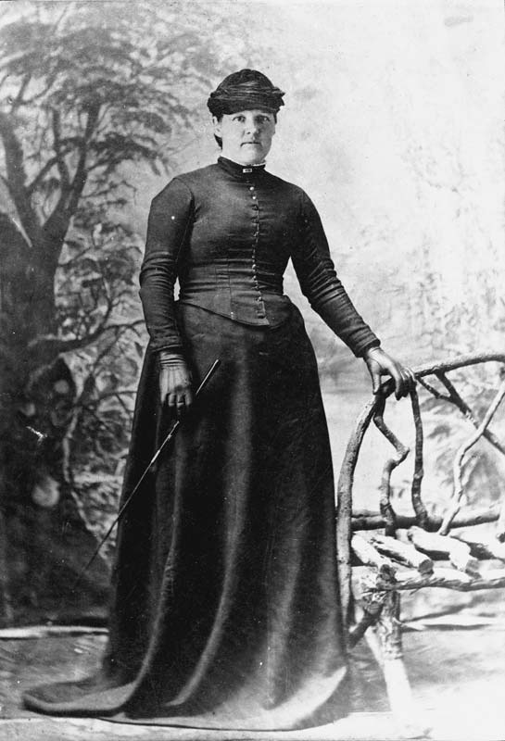
Unlike the rhetorical danger of creating competing ethea within a community, 19th-century women’s fashion STATEMENTS also came with truly physical and perilous dangers. While we may not consider 19th-century women’s efforts to leave the home and enter society as physically dangerous, women of this era found the freedom to enter and converse in public so desirable that they often chose to maintain the fashion standard that allowed them to enter society, without consideration for how those fashions might cause harm to their bodies. A prominent fashion style of the 19th-century was the corset, the body harness that laced and strapped around a woman’s mid-section to sinch the waist and create an hourglass figure. While the corset was particularly dangerous for women’s bodies, causing great restriction and severe compression on their internal organs, the perils of corset wearing significantly increased during pregnancy (Figure 9). However, despite these dangers, 19th-century women still chose to wear the corset, as Lori Duin Kelly explains, “Being fashionable, a term equated in the period with having a narrow waist, allowed women to maintain access to the public sphere and to resist exclusive consignment to the private one of the home which was the designated space for visibly pregnant women in the 19th century” (1). Kelly further states that “…fashion was crucial not only to a woman’s self-definition within Victorian society, but also to the sanctioned – albeit limited – sources of power which she was allowed to exercise there” (2).​ Thus, despite the detrimental health issues that the wearing “of corsets even into advanced stages of pregnancy [which] not only affected pregnant women’s health, it also had the long term effect of ruining them as mothers,” women chose to sport a fashion that allowed them to gain access to the public sphere and delay their return to the home for as long as possible (5). ​
Figure 9, Elizabeth Matilda Shewry in riding clothes. Alexander Turnbull Library, 1894, teara.govt.nz/en/photograph/26159/pregnant-woman-1894/.
Finally, beyond the dangers of fashion and physical health concerns, 19th-century fashion STATEMENTS also met with some pushback from other society members, particularly those of the other sex. While examples of support for women engaging in public discourse do exist, such as with John Wesley and Brigham Young, other 19th-century men did not endorse women entering public discourse, with some fearing that women’s physical presence in public conversation would have detrimental effects on the men in the audience. Carol Mattingly quotes Henry G. Ludlow’s opinion of women addressing men in a public space, saying:
I will not consent to have women lord it over men in public assemblies…She has no business to come into this meeting and by speaking and voting lord it over me. Where woman’s enticing eloquence is heard, men are incapable of right and efficient action. She beguiles and blinds men by her smiles and her bland and winning voice…Men have not enough strength of mind to resist the magic of woman’s appeal, when it is made to their gallantry” (“The Spirit of Slavery,” qtd by Mattingly 37).
While it could be argued that 19th-century men just needed to learn to self-control, Ludlow’s concerns reflect the broader negative reception of women in public discourse - not for women’s lack of intellect or ability TO engage, but purely for the struggle men would suffer from the enticement of women’s physical presence by her looks and fashions. Thus, this danger of 19th-century women’s fashion STATEMENTS raises a continued question today of when is fashion a persuasive mode of language and when is it, as Ludlow feared, a form of manipulation.
Scholarly Considerations for Fashion STATEMENTS
By addressing the dangers of 19th-century women’s fashion STATEMENTS patterns emerge that are essential for scholars to consider when seeking to identify woman/women’s language and their available means to participate in public discourse. The most prominent and identifiable consideration is that scholars have created the narrative for what counts as women’s fashion STATEMENTS, including who is included/excluded from the narratives we create. While rhetoric and feminist scholars have sought to bring out the voices of those often erased or silenced, in doing so, certain voices end up being elevated above others or ethos identities end up being generalized across a specific rhetorical genre. For scholars to overcome biases and ideological focuses that are inherent in rhetorical scholarship, we need to acknowledge our own perspectivism as scholars and note the potentials for misappropriation given our perspectives.
Melissa Ballanta and Alana Piper provide a significant example of how scholars can unintentionally misappropriate fashion options as fashion STATEMENTS in their research regarding the Flash Style of 19th-century disreputable women. In examining police reports and court documents, Ballanta and Piper note that scholars have resisted investigation into low-class women, stating:
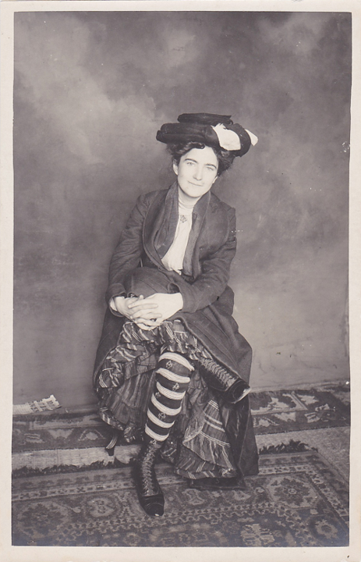
…[Because] disreputable women in flash dress have attracted little from historians…Historians of prostitution tend to refer only briefly to sex workers’ sartorial style... Problematically, too, the small number who do investigate the dress practices of working-class women have tended to do so as part of a search for advance evidence of the 1920’s ‘Modern Girl’ (58)
Figure 10. Goldman, William. “Working Girls: An American Brothel Circa 1892.” Picture 1, https://www.juxtapoz.com/news/photography/working-girls-an-american-brothel-circa-1892-features-unseen-photos-from-william-i-goldman-nsfw/
As Ballanta and Piper explain, examples of 19th-century low-class workers have not only suffered from missing in historical investigation, but they have also consistently suffered appropriation as precursors to the ‘Modern Girl’ because of their Flash Style dress (Figure 10). As a counter to the pre-‘Modern Girl’ narrative, Ballanta and Piper detail that most of the 19th-century disreputable women - thieves, prostitutes, and factory girls - created their fashion style out of what they could get their hands on, or, “To put this another way: flash women made eclecticism into an aesthetic virtue out of necessity” (63). For Ballanta and Piper, the call to recognize the misappropriation of 19th-century disreputable women as setting the stage for modernity, is a call for scholars to look even further past Cheryl Glenn’s boundaries of what counts as rhetoric, to include records like police records and court documents, where information regarding understudied populations and peoples are more likely to be found. Additonally, Ballanta and Piper encourage scholars to consider their own perspectivism that they bring to their research to avoid misappropriation of a (un/dis/re)covered voice.
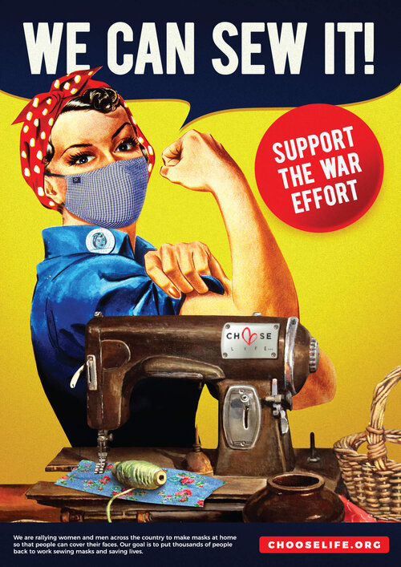
As feminist rhetorical scholar, Letzia Guglielmo describes, feminist rhetorical theory attempts to “Recover women’s voices and their work, [by] identifying omissions, erasures, and silences” (Guglielmo). However, current scholars seeking to identify voices silenced, omitted, and erased, must consider how to group women into respective ethos identities and recognize how their groupings result in the inclusion/exclusion of different women’s voices. During the recent Covid-19 pandemic, Min-Ha T. Pham describes the effects of marginalizing one ethos of women over a preferred national narrative through the textile work of mask making. She writes:
Figure 11. Rosie the Riveter Seamstress. Choose Life, 2020, www.chooselife.org/rosie.
Rosie the seamstress…as [the] name suggests, at-home mask-making in the context of Covid-19 is being interpreted as a gendered form of civic participation based on traditionally feminine skills of sewing and crafting as well as moral, spiritual, and cultural uplift… “Rosie the Seamstress” is uplifting, but it’s also a narrative that pushes women of color, low-income women, and immigrant women to the margins of the US cultural and social imaginary… (316-317)
As Pham explains, garment workers in both New York, Los Angeles, and Southeast Asia all suffered labor and wage losses because of the pandemic, but were then forced back to work, in less-than-ideal health conditions because of the need for PPE and face masks. Yet, the narrative in the United States propagandized the need for middle-class, white women to assume the call of mask making, which resulted in a narrative that promoted one rhetorical ethos by negating and marginalizing another.
Returning to my opening example of the 2019/2020 Democrat Congresswomen wearing white to the State of the Union Addresses, their fashion STATEMENTS promoted a narrative of inclusivity for all women’s voices. When considering Ryan, Myers, and Jones’ ecological ethos, however, the fashion STATEMENT of wearing white as a form of solidarity for women’s issues does not provide a complete account of all women included in the narrative. Just as 19th-century women like Jane Manning James, Frances Wright, and disreputable women do not fit the mold of the narrative created about 19th-century women and the different ethos genres of fashion STATEMENTS built by scholars, so too are women today still subject to issues of inclusion/exclusion in the narrative given about the fashion STATEMENTS they become attributed to. Therefore, to continue to incorporate fashion STATEMENTS of those left outside the established narrative, scholars need to continue their endeavors to broaden what counts as rhetoric and how rhetorical terms are applied, as well as look for examples of rhetoric in unlikely places, to include more in the narrative; in doing so, we can, as Thomas Sheridan suggests, identify language “by anyway or methods, whatsoever” (965).

Works Cited
Bellanta, Melissa, and Alana Piper. “Looking Flash: Disreputable Women’s Dress and ‘Modernity,’ 1870-1910.” History Workshop Journal, no. 78, Oxford University Press, 2014, pp. 58–81, http://www.jstor.org/stable/43299026.
Bizzell, Patricia. “Frances Willard, Phoebe Palmer, and the Ethos of the Methodist Woman Preacher.” Rhetoric Society Quarterly, vol. 36, no. 4, [Rhetoric Society of America, Taylor & Francis, Ltd.], 2006, pp. 377–98, http://www.jstor.org/stable/3886030.
Booth, Catherine. “Female ministry; or, Woman’s right to preach the gospel.” 1870. https://www.google.com/books/edition/Female_ministry_or_Woman_s_right_to_prea/E6lgAAAAcAAJ?hl=en&gbpv=1&dq=catherine+booth+female+ministry&pg=PA1&printsec=frontcover#v=onepage&q&f=false
Enoch, Jessica. “Embroidering History: The Gendered Memorial Activism of the Daughters of the American Revolution.” Nineteenth-Century American Activist Rhetorics, Edited by Patricia Bizzell and Lisa Zimmerelli, Modern Language Association of America, 2021, pp. 207-218.
Fleckenstein, Kristie. “Aesthetic Daughters and Civic Mothers: Collective Identity and the Visual-Verbal Rhetorics of the New Negro Woman.” Nineteenth-Century American Activist Rhetorics, Edited by Patricia Bizzell and Lisa Zimmerelli, Modern Language Association of America, 2021, pp. 249-264.
Glenn, Cheryl. “Remapping Rhetorical Territory.” Landmark Essays on Archival Research, edited by Lynee Lewis Gaillet, Helen Diana Edison, and Don Gammill, Jr., Routledge, 2016, pp. 63-77.
Guglielmo, Letizia. “Feminist Rhetorics: Identifying Omissions, Silences, and Erasures.” History of Rhetoric II, Georgia State University, Classroom South 501, 21 February 2022, Atlanta, GA. Guest Speaker.
Kelly, Lori Duin. “Crossing the ‘Bearing’ Straits: Women’s Maternity Dress in the 19th Century.” Studies in Popular Culture, vol. 21, no. 1, Popular Culture Association in the South, 1998, pp. 1–12, http://www.jstor.org/stable/23415262.
Lang, Cady. “Here’s Why the Women of Congress Wore White for the 2019 State of the Union Address.” Time, time.com/5518859/state-of-the-union-2019-white. Accessed 9 April 2022.
---. “Why Democratic Congresswomen Wore White Again to Send a Message at the State of the Union.” Time, time.com/5777514/women-wearing-white-state-of-the-union. Accessed 9 April 2022.
Locke, John. “An Essay Concerning Human Understanding.” History of Rhetoric, edited by Patricia Bizzell, Bruce Herzberg, and Robin Reames, Bedford/ St. Martin’s, 2020, pp. 887-901.
Mattingly, Carol. “Friendly Dress: A Disciplined Use.” Rhetoric Society Quarterly, vol. 29, no. 2, [Rhetoric Society of America, Taylor & Francis, Ltd.], 1999, pp. 25–45, http://www.jstor.org/stable/3886084.
Mueller, Max Perry. “EPILOGUE.: Performing Red, Black, and White American.” Race and the Making of the Mormon People, University of North Carolina Press, 2017, pp. 212–32, http://www.jstor.org/stable/10.5149/9781469633763_mueller.12.
Pham, Minh-Ha T. "“How to Make a Mask”: Quarantine Feminism and Global Supply Chains." Feminist Studies, vol. 46 no. 2, 2020, p. 316-326. Project MUSE, doi:10.1353/fem.2020.0028.
Rethinking Ethos: A Feminist Ecological Approach to Rhetoric, edited by Kathleen J. Ryan, Nancy Myers, and Rebecca Jones, Southern Illinois University Press, 2016.
Sheridan, Thomas. “From A Course of Lectures on Elocution. Lecture VI.” History of Rhetoric, edited by Patricia Bizzell, Bruce Herzberg, and Robin Reames, Bedford/ St. Martin’s, 2020, pp. 962-972.
Sohan, Vanessa Kraemer. “Lives, Letters, and Quilts: Women and Everyday Rhetorics of Resistance.” University of Alabama Press, 2020.

